Towards a global score for Implicative Dilemmas

# Víctor Rouco

# Universitat de Barcelona. Departament de Personalitat, Avaluació y Tractament Psicològics

# Abstract:

*Recent studies reveal that cognitive conflicts can be factors to be considered with respect to the presence of mental disorders and the psychotherapy processes. We have defined different types of internal conflicts according to Personal Construct Theory. One of them is Implicative Dilemmas, which are assessed with the Interpersonal Repertory Grid Technique. Previous studies used the number of Implicative Dilemmas to assess the overall degree of cognitive conflict in a subject, however this measure has important limitations. In this study we compare the number of Implicative Dilemmas with other measures that assess the overall influence of Implicative Dilemmas in mental disorders. We prove that the Proportion of the Implicative Dilemma and the Proportion of the Intensity of Conflict based on Implicative Dilemmas are better measures to assess the amount of conflict in a Repertory Grid. We also test their efficiency for explaining depression severity and global functioning alongside other cognitive facets measured with the Repertory Grid Technique.*

# Keywords: *Implicative dilemmas, Constructivism, Repertory Grid Technique, Personal Construct Psychology, Clinical Psychology, Major Depression, Cognitive Conflicts.*

# Introduction

People in need of psychological attention often seek for a change in different aspects disturbing their mental health. These changes can be associated with behavioral outcomes and mood but quite often they go beyond those by involving attitudes, positive affect, ideas, beliefs… While some of them occur naturally and in an unnoticed manner, some others are perceived as extremely difficult to achieve and can lead to moments of serious suffering and confusion. Besides people usually find hard to understand the difficulties of patients to accomplish those changes as they may seem simple from an external perspective. This phenomena is known as the *neurotic paradox* (Mowrer, 1950).

A key concept to understand this struggle is the cognitive conflict. Generally speaking, a cognitive conflict can be defined as an internal process characterized by the co-existence of two opposite attitudes concerning a given object or course of action. Conflicts produce blockage in the course of action and usually incurs in symptoms that influence the subject in several psychological facets.

Since 1990’s there has been an increase on the number of studies exploring the role of cognitive variables[1] in the onset and maintenance of different mental disorders. For example: depression (e.g. Phillips, Hine, & Thorsteinsson, 2010), bipolar disorder (e.g. Alloy et al., 2005) or social anxiety (e.g. Hofmann, 2007). However, little attention has been given to internal conflicts despite of being a big issue in earlier psychological views; like psychoanalysis, cognitive-social theorists, or Piagetian psychology (Feixas, Saúl, & Ávila-Espada, 2009, for a review).

Although there were some attempts to operationalize and assess internal unresolved conflicts, they weren’t satisfactory enough for therapeutic aims. Some of those proposals gave rise to assessment tools that define the items *a priori*, based on the theory of the proponent. These methods do not take into account the qualitative aspect of the phenomena in the client’s own personal terms. Some other attempts, focused in the motivational aspect of the conflict, are quite affected by social-desirability and aren’t well suited for enriching psychotherapeutic practice (e.g. Emmons & King, 1988). These difficulties have left cognitive conflicts outside the boundaries of EBP[2], leaving the importance for intervention unproved.

My current research group has made some progress in this area and we are still working to advance the knowledge on cognitive conflicts and its relevance in clinical psychology and personality. We have built an evidence-based series of studies inspired in the theoretical groundwork proposed by Kelly, in his Personal Construct Theory (PCT) (Kelly, 1955). It also provides tools for a better conceptualization and operationalization of different types of internal conflicts.

In order to understand better our study, it is important to explain some basics of PCT. According to PCT, individuals are proactive subjects who give meanings to different facets of subjective experience, and thus construct their own reality based on previous constructions. Those set of meanings arise whenever the individual realise a new feature or a new state of an object that was never aware of it before. When an individual depicts a difference in the phenomenal universe a conceptual bipolarity arises in his/hers understanding of the reality. One pole of this new property of reality will be the previously expected condition, whereas the other pole will be the new aspect he/she has apprehended. Although the previous condition, that of the first pole, existed before, the subject was never aware of it, as there was no contrast allowing to take out the part from the whole. We give the name of *personal construct* of this bi-polar part of perceived reality, and through this process we state that the individual constructs reality in its own manner.

We use the interpersonal repertory grid technique (RGT) as the assessment device to match some of those aspects of reality (constructs from now on) with the attributions that the individual does for his and other’s behavior. With this tool we analyze both qualitatively and quantitatively the relationship of the elements (people) with the constructs. Most importantly for this study, we evaluate how the subject perceives his own personality (self now), and the hypothetical personality of an ideal of self, that we include in the set of elements.

Figure 1

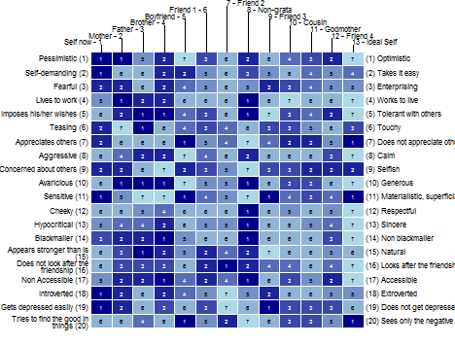

Extraction of a Repertory Grid (from the package OpenRepGrid; source of data: Feixas & Saúl, 2004)

Comparing the scores given by the subject to the actual self and to the ideal self we can detect the constructs on which the subject desires a change[3], and the constructs on which the individual perceives no need for a change[4]. The first type of constructs is called *discrepant constructs* (see construct number 19 in *Figure 1: “Gets depressed easily” vs. “Does not get depressed easily”*), the second type is termed *congruent constructs* (construct number 9: “*Concerned about others*” vs. “*Selfish*”).

The type of internal conflict that we are studying arises whenever those types of constructs are related to each other (e.g., the ratings given to the set of elements of the grid in these two constructs correlate, r > 0.34) in a conflicting way. In those situations, the subject perceives the need for a change (discrepancy between his or her actual and ideal self), but the desired pole is correlated with the pole of a congruent construct that is not attributed to the self nor is wished for the ideal self. Then the desired change would imply an undesired shift on a desirable aspect of his/her personality. This is the notion of an *implicative dilemma* (ID). IDs were first defined by Hinkle (1965) and they have been addressed recently in the constructivist approach (Feixas et al., 2009an).

Figure 2

*Example of an Implicative Dilemma. The congruent and discrepant constructs are related in a conflicting way[5].*

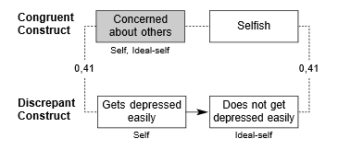

Our research group has contributed to the understanding of this phenomena and its implications in clinical psychology and personality. Recent papers reveal that the presence of IDs in clinical samples is significantly higher than in non-clinical ones (e.g., Feixas et al., 2009), and that there is an improvement of disorder-related symptoms associated with the resolution of IDs (Feixas, Saúl, Winter, & Watson, 2008). Same results were found with a larger sample of depressive patients, pointing out the importance of the ID also in global functioning and in symptom severity (Feixas, Montesano, Compañ, 2014). There is a constant increase in the number of studies suggesting that implicative dilemmas play a role for the genesis and maintenance of most psychological disorders. They also show that different kinds of psychotherapy help overcome implicative dilemmas restoring psychological balance and mental health (although most of clinicians are unaware of it). Research groups from different universities have joined their efforts to study implicative dilemmas using the umbrella of the Multicenter Dilemma Project (<http://campus.usal.es/~tcp/>).

I had pointed out the increasing importance of IDs, its potential to be treated as an important predictor for mental unbalance and to be a key element in focused psychotherapy. However, any research on implicative dilemmas has a weak point it should be solved. Previous studies were conducted using ID’s descriptives, like the number of IDs in a grid, or the presence/absence of IDs. Nevertheless these descriptive values aren’t the best possible estimators of implicative dilemmas. On one hand, the length of the grid is not defined a priori and it rather depends on the number of constructs elicited by the subject, hence construct length differs from one grid to another. On the other hand, we consider not all implicative dilemmas equally important: higher correlations would mean a greater conflict. A global score that would quantify the strength or the influence of implicative dilemmas in a grid should take care of those two factors, and this is the main question for this paper.

There were some previous attempts for quantifying implicative dilemmas globally. They gave rise to two different global indexes: the Intensity of the Implicative Dilemma (*IDI*), and the Proportion of the Implicative Dilemma (*PDI*). IDI is computed by summing the absolute values of the correlations of each ID and dividing by the number of IDs. The most important disadvantage of this measure is that it does not take into account of the length of the grid.

PDI is computed by dividing the number of dilemmas by the possible number of implicative dilemmas in a grid given the overall number of constructs and then multiplied by 100. The weakness of this measure is not to consider the strength of the association among discrepant-congruent constructs.

We have recently developed two measures that join attributes from the former two indexes. Intensity of Conflict based on Implicative Dilemmas (*ICDI)*, like IDI, is computed by summing the absolute values of the correlations of each ID, the resulting score is lately divided by the number of constructs in a grid. Proportion of Intensity of Conflict based on Implicative Dilemmas (*PICDI)* adds control for the combinative probability of finding an ID as PDI. PICDI would theoretically be a more efficient global index as it subsumes the strengths of the two first indices (IDI and PDI).

The aims of this is study are to test which of these global measures give better indicators for the conflicting nature of a grid (based in IDs). It also assess the suitability of these measures to predict mental disturbance in a sample of major depressive patients.

For this purpose I have first tested which of the indexes best classify the subjects on the type of sample (clinical vs. control). Once the best measure is identified, I have proposed cut-scores for the index, based in the ROC method, to determine conflict severity, as it might be important for clinical settings. I have finally proposed a model that include different cognitive variables (all of them measured with the RGT) in addition to the global scores to test the extent of the explanatory power of the available cognitive variables in predicting the external tests criteria (BDI-II and GAF).

I consider the following hypothesis: H1. At least one global index will predict the criteria more efficiently than the number of implicative dilemmas in the grid. H2. Best indexes will be the ones that control the grid size and the magnitude of the correlations (i.e. PICDI is the most efficient index) H3. A model that yields several cognitive variables, in addition to the global score for the implicative dilemma, would provide a substantive proportion of predictive power for depressive disorder severity.

If these hypothesis are confirmed the current state of the research on implicative dilemmas would be improved, while we could ensure a better quantitative efficacy of the repertory grid as a clinical assessment technique. This would not only provide idiosyncratic, qualitative information, but also trustful quantitative measures and a useful overall explanatory power to assess mental health (at least understood as opposite to major depression). We would have found a global score that could reflect adequately the overall level of conflict (based on IDs) in a grid, in a more subtle way than the basic count of IDs. And we also would have more information to improve the global measures in the future understanding which factors make them more appropriate.

**METHOD**

# Participants

Our study will use a dataset (Feixas et al, 2014) formed by 264 observations of a sample of both patients (n = 161), diagnosed with major depression, and a community sample (n = 103) with no (or very low) symptoms of depression. Age was between 21 and 71 years old (Mean = 46,20; SD = 12.65). There was a higher number of females that of males in the sample: 200 female participants (75.7%), 64 males (24.3%).

Sampling method was non probabilistic, convenience type, which may limit the implications of the study, as assignment was not done at random. It reflects real life circumstances and economic and pragmatic limitations. In this case a completely randomized assignment of individuals to conditions was not possible[6].

The clinical sample was homogeneous in some respects: all the participants were recruited from several community health care centres of the city of Barcelona (Spain) and its surrounding area. They all fulfilled the criteria for the diagnosis of major depression. All patients knew that they could deny their personal information to the study, as the informed consent specified. No subjects were paid for the completion of the assessment, and we took care that no one felt any kind of coercion or expectance of reward other than the intrinsic benefits of the procedure.

A community sample was set as control to maintain comparable values in all variables except for the presence or absence of the psychological disorder. To compensate for their cooperation, some individuals recruited from civic associations were offered free psycho-educational talks. Other participants were recruited using the snow-ball method involving students and participants.

We ensured that this study was under all ethical considerations, and individuals weren't at any kind of risk. Not only non-maleficence was pursued, but also psychological beneficence in both clinic and control samples. We have been always responsible of following the standards of conduct for a good psychological practice as proposed by American Psychological Association; completely honest about the field's available knowledge and limitations; ensured a process of the maximum quality according to our capabilities; and absolutely respected the rights of the individuals to keep their privacy and self-determination.

# Design and Measures

The timing design used was cross-sectional, that is one-time measure. We have chosen an observational approach therefore we have not manipulated variables or carried on any follow-ups, and the settings of the study resemble real life conditions. As consequence, no causation has been inferred.

Data collection type was both qualitative and quantitative. Tools like BDI or GAF assesses quantitative features, semi-structured interviews (SCID-I) assess qualitative outcomes, and the main tool we use (the Repertory Grid Technique), collects both quantitative and qualitative data.

This is not an anonymous study, however confidentiality was carefully ensured by assigning codes to every participant and making sure that the relational sheet in where names and codes were explicit wasn’t available for anyone, safely kept by a few researchers of the study.

We didn’t need to adapt any questionnaire as all of the tools we used had an already available and valid Spanish translation.

# *Beck Depression Inventory – II (BDI - II)*

The BDI-II created by Beck, Steer and Brown (1996) is a 21-item self-report instrument that measures depression. It is commonly used in clinical settings as it has shown strong psychometric properties. The usage of BDI-II is linked to the assessment of symptom severity in major depression disorder. The authors have reported an internal consistency of .92, which is a very good reliability score. We have used the Spanish adaptation (Sanz, Navarro, & Vázquez, 2011). Internal consistency of the Spanish adaptation was .92 in clinical and .93 in community samples. Factor analysis conducted in a Spanish sample showed a similar structure of two factors, and content validity was also ensured by examining the content of the items in relation to the theoretical symptoms related with the disorder.

# *GAF*

This is the Spanish adaptation of the Global Assessment of Functioning tool (GAF), developed by American Psychiatric Association in 1994. It is a measure focused to assess items of the V axis of DSM IV, which entails the psycho-social functioning of the subject. Some authors have found a high (K= .826) inter-rater reliability of the Spanish translation (García-Nieto et al., 2012), and a construct validity of rxy = .54 , which defines a good validity for the measure (same authors).

In our study only clinical sample data was collected for this measure.

# *Structured Clinical Interview for DSM-IV Axis I Disorders (SCID – I)*

It is a semi-structured interview designed to assess mental disorders as specified by the axis I of DSM IV. It has found an inter-rater reliability of .61 for clinic patients and .37 for non-clinic sample. There has been found an adequate test-retest reliability of the score according to the authors (First, Spitzer, Gibbon, & Williams, 1997). Validity of the measure hasn’t been tested as the tool is frequently used as a criterion for validate different tests (Shear et al., 2000). However it has been used by researchers for several years to identify symptoms of a mental disorder, face validity is thus ensured by clinical agreement.

# *Repertory Grid Technique*

Proposed by Kelly (1955), the Repertory Grid Technique (RGT) is a semi structured interview. It provides both quantitative and qualitative data. Although there are different types of repertory grids, we focus in the interpersonal modality. In this type of grid, the subject has first to select close and important people in his/her life (e.g. parents, siblings, important members of the family, close friends…), and the interviewer adds an actual self, a *persona non-grata*, and an ideal self. These will be the elements of the grid. Then, the interviewer asks for differences and similarities between two elements to elicit the participant’ personal constructs. For every elicited characteristic, an opposite pole would be asked, so the dyads are displayed as rows in the grid. The process is repeated again and again with different pairs of elements serving to elicit new constructs until both the interviewer and the interviewee have real difficulties in generating new constructs, and all of those that emerge are being repeated, even though different labels may be used. Finally, the interviewer asks the subject to rate every element of the grid according to each construct on a 7 point Likert scale. The final resulting would be similar to *Figure 1.*

When the process is completed, data is entered in the software for analysis. In this study we use the GridCor software (Feixas & Cornejo, 2002) to compute the measures.

Psychometric properties of the RGT are yet being tested. However, there are several studies that have found test-retest reliabilities ranging from .61 to .92 (Feixas, G., y Cornejo, 2002).

The RGT provides a wide range of measures associated with personality outcomes. In the present section I will explain those which are relevant for this study:

1. *Global indexes for the implicative dilemma:*

As I’ve pointed out in the introduction, we identify an implicative dilemma whenever a discrepant construct is correlated with a congruent one in a conflictive way with a Pearson’s correlation score of r = 0.35 or more. However, several implicative dilemmas can be found in a single grid. The following measures try to summarize the strength of the implicative dilemmas on a single grid. These are the mathematical expressions for the available global scores of the implicative dilemma, which were explained in detail in the introduction section.

1. IDI : ${√\sum{r^{2}} \atop }$ $×100$
2. PDI : $\frac{d}{\left({n!}/{2\left[\left(n-2\right)!\right]}\right)} ×100$
3. ICDI : $\frac{√\sum{r^{2}}}{n} ×100$
4. PICDI: $\frac{√\sum{r^{2}}}{({n!}/{2\left[\left(n-2\right)!\right]})} ×100$

*Where: n = Number of constructs.*

*d = Number of implicative dilemmas.*

$\sqrt{\sum{r^{2}}}=$*The absolute value of the sums of the correlations for the implicative dilemmas*

*PDI: Proportion of Implicative Dilemmas*

*PICDI: Proportion of the Intensity of Conflicts based on Implicative Dilemmas*

*ICDI: Intensity of Conflicts based on Implicative Dilemmas*

*IDI: Intensity of the Implicative Dilemma*

The last two measures (ICDI and PICDI) aren’t computed with the GridCor software, as they are still proposals under research.

One important property of the measures is that the median of the scores in all the community samples that we have studied is near zero. In clinical samples there is also a high tendency of positive skewness, showing small values in central tendency measures. Therefore the scores tend to produce a big floor-effect that should be considered. This property produces a non-normal distribution that can affect the posterior analysis. Figure 2 shows the density curves of the four measures in our sample.

*Figure 2*

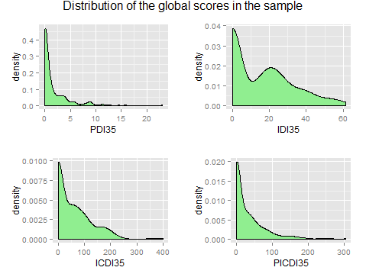

1. *The polarization index*:

This index is used to measure certain aspects of the client’s cognitive structure. It gives information regarding extremity of construing. Higher scores mean rigid cognitive structures, by which the subject’s attribution of self and others characteristics would be very strict, with no consideration of intermediate aspects. Oppositely, a loose cognitive structure indicates an understanding of self and others’ attributes is considered with nuances, reflecting the differences between the elements in their allocation to each construct.

In grids where the elements are rated consistently using high and low scores (1 and 7) the polarization index will raise. In this sense, the polarization index is a way of measuring extreme response styles in the grid. It should be also emphasized that highly polarized grids have a higher probability of presenting implicative dilemmas, as more discrepant and congruent constructs are defined.

1. *Self – Ideal Discrepancy:*

It is computed attending to the euclidean distance of the scores given to the “actual self” and the “ideal self” elements in the RGT. This measure is considered a good indicator of self - esteem, thus it can be meaningful for a model of depression (Feixas, Erazo-Caizedo, Harter, & Bach, 2008).We have found a mean of 0.24 (SD = 0.09) in community samples.

Figure 3 shows the distribution of self – ideal discrepancy scores in our sample, with density curves showing differences in the clinical and control samples.

Figure 3

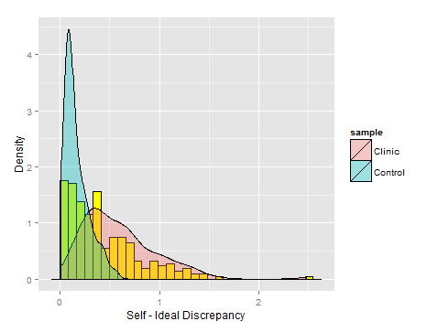

# Procedure

The object of the first set of analysis was to obtain statistical evidence about the efficacy of the indexes classifying subjects across clinical vs. control sample. We used the Receiver Operator Characteristic method to reach this goal and performed this analysis with the *pROC* package (Robin et al., 2011) from R open software. This statistical method was first developed in World War II for signal detection in radars, and now is widely used for testing the efficacy of tools classifying subjects in medical settings. In a ROC curve, the true positive rate (Sensitivity) was plotted in function of the false positive rate (1-Specificity) for different cut-off points of a parameter. Each point of the curve represents a pair of sensitivity/specificity threshold for a given score in the classifier (the index in our case). The technique allows the researcher to calculate the Area Under the Curve (AUC), a non-parametric procedure by which we can estimate the probability of the test yielding a higher value for a random individual with the disorder than for another individual who doesn´t have the disorder (Streiner & Cairney, 2007).

In addition we have calculated the relative importance of the predictors to the factor with the R’s *relaimpo* package (Grömping, 2006). This could give us an estimate of the proportion of variance explained by each predictor to the factor.

Once the efficacy of the measures classifying participants in the sample has been tested, we should obtain cutting scores that would help psychotherapists to apply these indexes. The ROC method is very useful for this purpose, as it gives information about the probability of making mistakes in both directions of the classification (false negatives and false positives), for each score in the tool. The decision of setting a score as a cutting point depends in the willingness to give preference to one type of error over other.

For more thorough understanding of the efficiency of the measures, it would be interesting to estimate the power of ID indexes for predicting depressive symptoms alongside other cognitive measures that are also provided with the Interpersonal Grid Technique. To do so, we have used a multiple linear regression model, setting the BDI-II and the GAF as dependent variables. We have computed these analysis with the *stats* R’s package (R Development Core Team, 2011). The analysis would give us a general predictive score for the outcomes of the RGT for depression, and also the specific contribution of the global scores in this prediction, when taking into account the other measures.

# Results

# *Classification efficiency of the indexes*

*Figure 4* is a plot of the ROC curve of the different indexes’ scores classifying the subjects in the clinical and control samples. The first thing to observe is the diagonal line that splits the plot. This line represents 50% probability of the test correctly diagnosing the criteria, that is, classifying individuals randomly under the different samples. The perfect test would draw a ROC curve in the top-left corner of the graph. Therefore the best indexes would draw a line trajectory closer to the top-left corner.

*Figure 4.*

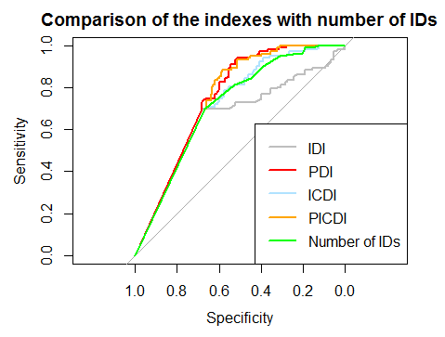

It is notorious the straight diagonal line that is common to all of our indexes from the beginning to almost half of our curve. This is due to the large amount of zeroes shown in our sample in relation to the number of implicative dilemmas (*Figure 3*). Zeroes are more present in the control sample than in the clinical one, and that’s why the diagonal is not overlapping the 50% classification line.

The first thing that is interesting when comparing the curves is that the IDI is the worst measure classifying subjects in the sample, worse than the number of implicative dilemmas present on a grid (which classifies similarly than ICDI). Second, we observe that both PICDI and PDI are the best measures classifying individuals in the clinical and control samples. We can’t distinguish between instruments whose lines cross at any point in the ROC curve, thus both PDI vs. PICDI and ICDI vs. Number of IDs are equivalent from a statistical point of view.

In *table 1,* we show the estimates for AUCs and its 95% confidence interval. With this non parametric statistic we can identify how accurately the indices classify the individuals in the sample. Our best measures classify about 75 % (70 – 80, 95% confidence interval) of the subjects correctly in the clinical and control samples, whereas IDI classifies approximately 66% (59 – 72, 95% confidence interval) of individuals correctly.

*Table 1*

*95% Confidence Interval for the AUC’s estimates in the studied indexes*.

|  |  |  |  |  |
| --- | --- | --- | --- | --- |
| Index | Lower bound CI 95% | Estimate | Upper bound CI 95% | |
| PDI | 0.702 | 0.754 | | 0.806 |
| PICDI | 0.698 | 0.750 | | 0.803 |
| ICDI | 0.665 | 0.721 | | 0.777 |
| Number of IDs | 0.663 | 0.719 | | 0.776 |
| IDI | 0.593 | 0.659 | | 0.726 |

*Where PDI: Proportion of Implicative Dilemmas*

*PICDI: Proportion of the Intensity of Conflicts based on Implicative Dilemmas*

*ICDI: Intensity of Conflicts based on Implicative Dilemmas*

*IDI: Intensity of the Implicative Dilemma*

In tables 2 and 3, we provide a subset of scores in the PDI and PICDI measures and its associated values of specificity and sensitivity. Note that the sensitivity of the test (that is, the amount of true positives) increases as the scores in the index are higher, and consequently the specificity of the classification decreases (the amount of true negatives). So if we would take the 0.08 score, we would have a probability of 30.1 % (1 - true positive, or sensitivity) of including a healthy individual in the clinical group, and a very similar probability (31.7 %) of making a mistake in the opposite direction, e.g., leave a subject with depression out of the treatment condition.

Table 2

*Sensitivity and specificity values for the Proportion of the Implicative Dilemma*

|  |  |  |
| --- | --- | --- |
| PDI scores | *Sensitivity* | *Specificity* |
| 0.080 | 0.699 | 0.683 |
| 0.170 | 0.709 | 0.683 |
| 0.184 | 0.718 | 0.683 |
| 0.190 | 0.728 | 0.683 |
| 0.592 | 0.796 | 0.596 |
| 0.635 | 0.825 | 0.596 |
| 0.885 | 0.893 | 0.553 |
| 0.955 | 0.903 | 0.547 |
| 0.995 | 0.913 | 0.547 |
| 3.449 | 0.990 | 0.286 |
| 3.535 | 0.990 | 0.280 |
| 3.645 | 1.00 | 0.280 |

Table 3

*Sensitivity and specificity values for the Proportion of the Intensity of Conflicts based on Implicative Dilemmas.*

|  |  |  |
| --- | --- | --- |
| PICDI scores | *Sensitivity* | *Specificity* |
| 0.750 | 0.699 | 0.671 |
| 4.075 | 0.699 | 0.665 |
| 7.105 | 0.699 | 0.658 |
| 7.650 | 0.709 | 0.658 |
| 17.095 | 0.796 | 0.634 |
| 18.445 | 0.806 | 0.634 |
| 30.567 | 0.893 | 0.516 |
| 31.302 | 0.903 | 0.516 |
| 31.965 | 0.913 | 0.516 |
| 61.270 | 0.990 | 0.317 |
| 61.445 | 0.990 | 0.311 |
| 61.740 | 1.00 | 0.311 |

Based in this results we suggest the score of 0.95 to be the cutting point in the PDI index, and 31.3 if we take PICDI into consideration. This means that the therapist should be pay attention to any important internal conflict whenever the patient’s score is above that threshold. We have found a probability of 90% of correctly classify a subject in the clinical sample, but we must be aware of the high probability (from 45% to 48%) of not classifying a mentally ill individual in the clinical sample because his/her score is below this threshold. This and other implications and limitations of the classification proposed will be explained in the discussion of this paper.

# *Predicting depressive symptoms and global functioning*

Treating BDI-II as the dependent variable, the proposed model is the following:

*Model 1:*

*BDI on*

*PDI + Self ~ Ideal Discrepancy + Polarization index + Interaction term (Index x Polarization)*

The interaction term is not a meaningful predictor in the model according to the ANOVA procedure that test that slopes are equal to zero. Therefore we will exclude this predictor from the model.

The proportion of variance of the factor explained by the model (Adjusted $R^{2}$) is 41.54 %, significantly different from zero (F3, 260 =63.29, p < 0.01).

Table 4

*Coefficients for Model 1*

|  |  |  |  |  |  |
| --- | --- | --- | --- | --- | --- |
|  | β | SE | T-value | p | $$Partial R^{2}$$ |
| Intercept | 10.907 | 1.930 | 5.653 | <0.001 | - |
| PDI | 1.026 | 0.271 | 3.790 | <0.001 | 0.070 |
| Polarization | -0.002 | 0.056 | -0.043 | 0.966 | 0.013 |
| Self-Ideal |  |  |  |  |  |
| Discrepancy | 27.005 | 2.345 | 11.516 | <0.001 | 0.339 |

*Where PDI: Proportion of Implicative Dilemmas*

*Table 4* shows the estimated coefficients for the predictors. The PDI index and the self- ideal discrepancy are significantly different from zero at a 0.05 alpha level. The polarization index is not different from zero given its high p-value.

The PDI coefficient (*β = 1.02*) implies that the score in the BDI-II increases 1.02 points for a 1 point increase in the PDI index (mean = 1.743, SD = 3.12), if all the other predictors hold. In the same direction, the self – ideal discrepancy coefficient indicates a 27 point increase in the factor for every one unit increase in the predictor. However, it is more useful to divide the coefficient by 10 according with the self – ideal discrepancy scores (mean = 0.42, SD = 0.36). Therefore a 0.1 increase in the predictor would produce a 2.7 increase in the BDI scores.

PDI’s percentage of variance explained of the factor is 7 %. The self – ideal discrepancy measure explains 33.9 % of the variance of the scores in the BDI-II, suggesting that it is a very important predictor in the model.

*BDI on*

*PICDI + Self ~ Ideal Discrepancy + Polarization index + Interaction term (Index x Polarization)*

If used the PICDI in the set of predictors, instead of PDI, the interaction term becomes significant as a useful predictor in the model (p = 0.023). The overall $R^{2}$ is 42.73% in the model, and the slopes are again different from zero (F4, 259 =50.06, p < 0.01).

Table 5

*Coefficients for Model 2*

|  |  |  |  |  |  |
| --- | --- | --- | --- | --- | --- |
|  | β | SE | T-value | p | $$R^{2}$$ |
| Intercept | 8.808 | 2.159 | 4.080 | <0.001* |  |
| PICDI | 0.152 | 0.041 | 3.737 | <0.001* | 0.098 |
| Polarization | 0.061 | 0.065 | 0.942 | 0.347 | 0.014 |
| Self-Ideal |  |  |  |  |  |
| Discrepancy | 25.610 | 2.380 | 10.760 | <0.001* | 0.307 |
| Interaction: |  |  |  |  |  |
| (PICDI x polarization) | -0.002 | 0.001 | -2.281 | 0.023 | 0.016 |

*Where PICDI: Proportion of the Intensity of Conflicts based on Implicative Dilemmas.*

*\*: Significant at a 0.0125 α level (Bonferroni correction of usual 0.05 α level).*

The polarization index and the interaction term are not significant predictors for this model. The interaction term fails to be significant if we apply a more restrictive approach based in familywise corrections like Bonferroni (threshold for p-values = 0.0125). The coefficients yield different values for the index, as the metrics of the PICDI are slightly different to the PDI’s (mean = 33.24, SD = 50.91). It is meaningful to multiply the coefficient this time, in order to get interpretable results. A 10 point raise in the PICDI would produce a 1.5 increase in the factor, if all the other predictors hold constant.

Both PICDI and the interaction term account for a higher percentage of explained variance than in the PDI’s case, while the partial $R^{2}$ decreased for the self – ideal discrepancy measure. Furthermore, the coefficients suggest that PICDI provides more predictive information of the BDI-II scores. If we compute the product of the coefficients with the mean of the indexes, we would find that the mean score of PDI predicts a 1.79 raise in the factor, while the mean score for PICDI predicts a 5.02 increase in the BDI – II.

Now let’s consider GAF as the dependent variable, this are the results of the following regression model:

*GAF on*

*PDI + Self ~ Ideal Discrepancy + Polarization index + Interaction term (Index x Polarization)*

Figures number 6 and number 7 suggests that the observation 99 is affecting the model’s normality distribution of residuals.

Figure 6

*Histogram of the distribution of the studentized residuals in the model.*

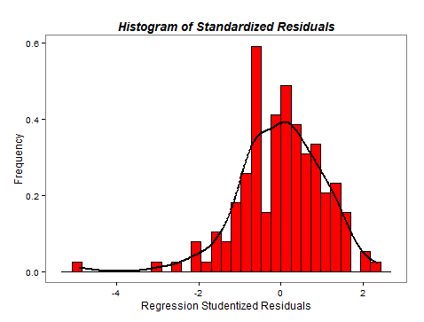

*Figure 7*

*Normal QQ plot of the studentized residuals. The assumption of linearity is compromised by the influence of an outlier.*

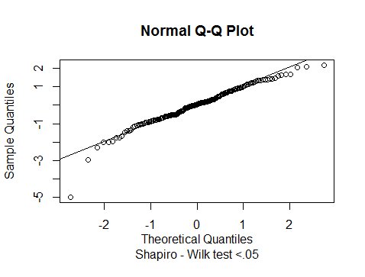

If we take a close look at the scores of the observation number 99 in the different variables, we see that the participant has a very low score in the factor GAF (24, which is the lowest score in our sample). In addition, the participant has scored 3.89 in the PDI, and 45.64 in the polarization index. Both of these scores are in the 3rd quartile of the distribution of those measures. This an especial case that take us to reconsider the scores at this stage of the study. Since this might have been consequence of a mistake when coding, the analysis will be done again isolating this subject.

The ANOVA procedure reveal that the polarization index and the interaction term are non-significant, thus we will exclude them for this model.

The adjusted R squared value is 13.6% for this model. The effects of the whole model are significantly different from zero (F2, 157 = 13.52, p < 0.01).

We now proceed interpreting the coefficient results.

Table 6

*Coefficients for Model 3*

|  |  |  |  |  |  |
| --- | --- | --- | --- | --- | --- |
|  | β | SE | T-value | p | $$R^{2}$$ |
| Intercept | 61.869 | 1.021 | 60.598 | <0.001 |  |
| PDI | -0.494 | 0.139 | -3.548 | <0.001 | 0.072 |
| Self-Ideal |  |  |  |  |  |
| Discrepancy | -5.029 | 1.391 | -3.615 | <0.001 | 0.075 |

*Where PDI: Proportion of Implicative Dilemmas*

Both the PDI and the self – ideal discrepancy yield significant results (p < 0.001). Although both predictors are given quite different coefficient estimates, this is again caused by the different metrics of the variables. The model predicts a 0.5 drop in the scores of the PDI for every one unit increase in the GAF factor, and a 0.5 drop for a 0.1 unit increase in the self – ideal discrepancy[7].

In this model, PDI accounts for a relative explained variance of 7.2 %, whereas the self – ideal discrepancy explains 7.5% of the variance of the factor scores in this model.

*GAF on*

*PICDI + Self ~ Ideal Discrepancy + Polarization index +*

*Interaction term (Index x Polarization)*

Although the p-values for the polarization index and the interaction term have dropped in the ANOVA test using PICDI, they are still non-significant and are therefore excluded.

The model explains 12.13 % of the variance of the factor, and the effects of the predictors are again significantly different from zero (F2, 157 = 11.97, p < 0.01).

Table 7

*Coefficients for Model 4*

|  |  |  |  |  |  |
| --- | --- | --- | --- | --- | --- |
|  | β | SE | T-value | p | $$R^{2}$$ |
| Intercept | 61.760 | 1.032 | 59.848 | <0.001 |  |
| PICDI | -0.028 | 0.009 | -3.120 | 0.002 | 0.062 |
| Self-Ideal |  |  |  |  |  |
| Discrepancy | -4.765 | 1.411 | -3.377 | <0.001 | 0.071 |

*Where PICDI: Proportion of the Intensity of Conflicts based on Implicative Dilemmas.*

Both predictor’s coefficient estimates are different from zero (p < 0.01). The model predicts a 0.02 drop in the factor for every one unit increase in the PICDI. That is a 0.2 drop for a 10 unit increase. It also predicts a 0.47 drop in GAF for every 0.1 increase in the self – ideal discrepancy, holding PICDI constant.

The prediction for the mean score of PDI is a 0.87 drop in the factor scores. A subject scoring the mean score in PICDI would decrease in 0.665 points in GAF according to our regression model.

The relative importance analysis informs that the PICDI yields for 6.2 % of the variance on the factor scores and that the discrepancy accounts for 7.1% of the variance in this model.

# Discussion

The results using the type of sample as criteria confirm the first hypothesis. The number of implicative dilemmas is a poorer measure of the conflicting nature of a grid than some global indexes, like PICDI and PDI, although it is surprising that it is still a better method to assess implicative dilemmas than IDI or ICDI. We have excluded both measures and the number of implicative dilemmas in the regression analysis.

It is noteworthy the comparatively high classification efficiency of the best indexes in the clinical and control sample. The AUC estimates provided a 75 % of correct classification for both PDI and PICDI indexes (70 to 80 % in a 95 % confidence interval). The notion of cognitive conflict is not a necessary condition to meet clinical criteria, but these results suggest that it may be a good indicator of mental health.

The most important characteristic to take into account for a global index is the number of possible implicative dilemmas in the grid. We shall also consider that the strength of the relationship between the discrepant and the congruent constructs does not have an effect on the efficiency of the indexes according to some criteria (type of sample and GAF), while it does according to other criteria (BDI-II factor). Effectively, in the light of the results our second hypothesis cannot be completely accepted. Our two proposals (ICDI and PICDI) are not as efficient as the former PDI when classifying individuals in the clinical and control samples nor when predicting global functioning. However the PICDI shows a higher power to explain the variance in depression severity (BDI-II) than the PDI.

The model that used GAF as dependent variable has reported different results. Both $R^{2}s$ were lower than in the BDI – II models. Suggesting that our measures are more efficient predicting depression severity than global activity. One possible reason for this result is that the GAF is more focused in the behavioral aspects of the mental disorder. We consider the RGT measures to show a more attributional aspect of psychological phenomena, thus predicting GAF at a lower degree. We can claim that the cognitive conflict also influences direct behavior, although to a smaller degree (13.6 and 12.13 % of the variance of the factor).

Comparing the models for depression severity and global functioning we found contradictory results. On one hand, results might suggest that the strength of the implicative dilemma is not so relevant to predict mental health issues (measured with the GAF). On the other hand, it might be possible that the influence of the strength of the implicative dilemma is important to predict the severity of depression. We have to work towards a better operationalization of what we consider to be core or superordinate constructs, as it may uncover the cause for these results.

Regarding the overall multiple linear regression model, we have successfully found a set of predictors that can explain a substantial degree of the variability for the BDI-II scores ($R^{2}=0.42)$, and a decent degree of variability of the GAF factor ($R^{2}=0.13).$ Nevertheless some of our models were affected by violations of OLS assumptions. Both models using BDI as criteria showed deviations from normality of residuals and homoscedasticity (Figures 8 to 11 in Append). PDI’s model using the GAF criteria incurred in some heteroscedasticity (Figure 14), and PICDI’s model predicting GAF did not seemed to strongly violate any of these assumptions (Figures 16 and 17). Therefore, we should better be cautious when claiming that we have confirmed our third hypothesis; some results may be inflated due to these violations of the assumptions.

The factor structure of the BDI-II has been addressed from different perspectives. The original Beck’s proposal consists of two different factors: cognitive and somatic-affective (Steer, Ball, Ranieri, & Beck, 1999). This proposal is compatible with the results of the BDI-II model since the RGT evaluates mainly cognitive items[8]. However, there is a lack of consensus regarding the appropriate factor structure for the BDI-II which does not allow us to provide an absolute conclusion on the basis of our results. Some authors suggest that a bi-factor model is a better solution (Brouwer, Meijer, & Zevalkink, 2012) than the former Beck’s proposal, because of the high correlation between the two above mentioned factors.

The predictive power of our model has been strongly affected by including the self – ideal discrepancy in our set of predictors. Self – ideal discrepancy appears now as a relevant variable to be taken into consideration for forthcoming research on the implicative dilemma, as well as on the explanatory power of the RGT as an assessment device.

The interaction term has been included to counter-balance the effect of extreme response biases in the appearance of implicative dilemmas. It is logical to understand the polarization index not only a pure cognitive rigidness estimator, but also an estimator of an extreme response style that may be caused by other variables[9]. In this sense, an interaction term is useful to denote a moderation effect, by which higher scores in the polarization index imply a higher variability in the implicative dilemma global scores. The interaction term was not significant in any model, although its influence is higher in models that include the PICDI amongst the set of predictors. Future studies must take this effect into consideration as it might become important for some models.

Concerning the cutting scores, I have proposed a threshold of PDI = 0.95 from which considering important the global conflicting nature of a grid (based in IDs)[10]. ROC method has classified 90% of our clinical sample above that threshold. However an important proportion of the control sample (45%) was also above it. A cutting score of the implicative dilemma can never be deterministic, it can only be informative and suitable for clinical purposes. This is due to the lack of specificity of the indexes classifying clinical – control[11]. The cognitive conflict is not a necessary condition for mental disorder. Most people face cognitive conflicts through their life (if not all, in line with Piaget’s development theory). A cutting score of the cognitive conflict is useful only for clinicians whose expertise allows them to judge the importance of the ID after assessing different psychological aspects. Therefore I strongly advice against using this cutting score solely to evaluate a patient’s cognitive conflicts. Practitioners have to assess their clients carefully, collect additional evidence and use their professional skills before considering an implicative dilemma as a key point for the psychotherapy process.

Finally, it is important to remark several limitations regarding this study. The most important limitation concerns the violation of OLS assumptions, which makes our linear regression models not completely trustable (aside the PICDI model for the GAF factor). The natural distribution of our indexes and the self – ideal discrepancy (shown in figures 3 and 4 in the measures section), may provoke a non-normal distribution of residuals and problems derived from heterokedasticity. It would be important for future research to find appropriate statistical methods to analyze our measures without having to consider the results somehow biased. At the light of these problems, we are very cautious not to make strong claims on the results and to point out the preliminary nature of this study.

Second the observational nature of the study implies that no causation can be inferred whatsoever. Third, we shall be very cautious when applying the findings on a different sample due to the type of sample collection that does not include complete randomization and local samples. The study doesn’t intend to elaborate absolute statements but to provide referential results that must be applied considering the differences in the samples prudently.

Fourth, the sample is gender biased. Nearly 80 % of it were female, and this bias can cause the finding of different results in studies that control for sex variables. However, several authors reported gender differences in seeking for mental health (Gove, 1972; Kessler, Brown, & Broman, 1981), so this sample bias actually reflects the normal tendency in real life settings.

# Additional software

*ggplot2* package for graphs (Wickham, 2011a).

*plyr* (Wickham, 2011b) and *MASS* (Venables & Ripley, 2002) packages for data analysis.

# References

Alloy, L. B., Abramson, L. Y., Urosevic, S., Walshaw, P. D., Nusslock, R., & Neeren, A. M. (2005). The psychosocial context of bipolar disorder: Environmental, cognitive, and developmental risk factors. *Clinical Psychology Review*, *25*(8), 1043–1075. doi:10.1016/j.cpr.2005.06.006

Brouwer, D., Meijer, R. R., & Zevalkink, J. (2012). On the Factor Structure of the Beck Depression Inventory–II: G Is the Key. *Psychological Assessment*. doi:10.1037/a0029228

Emmons, R. a, & King, L. a. (1988). Conflict among personal strivings: immediate and long-term implications for psychological and physical well-being. *Journal of Personality and Social Psychology*, *54*(6), 1040–1048. doi:10.1037/0022-3514.54.6.1040

Feixas, G., y Cornejo, J. M. (2002). *RECORD v. 4.0: Análisis de correspondencias de constructos personales [Aplicación informática]. Barcelona: Psimedia*.

Feixas, G., Erazo-Caizedo, M. I., Harter, S. L., & Bach, L. (2008). Construction of Self and Others in Unipolar Depressive Disorders: A Study Using Repertory Grid Technique. *Cognitive Therapy and Research, 32*, 386-400.

Feixas, G; Montesano, A; Compañ, V. (2014). Cognitive conflicts in major depression: Between desired change and personal coherence. *British Journal of Clinical Psychology*. doi:10.1111/bjc.12050

Feixas, G., Saúl, L. A., & Ávila-Espada, A. (2009). Viewing Cognitive Conflicts as Dilemmas: Implications for Mental Health. *Journal of Constructivist Psychology*, *22*(2), 141–169. doi:10.1080/10720530802675755

Feixas, G., Saúl, L. Á., Winter, D., & Watson, S. (2008). Un estudio naturalista sobre el cambio de los conflictos cognitivos durante la psicoterapia. *Apuntes de Psicología*, *26*, 243–255.

First, M. B. et, Spitzer, R. L., Gibbon, M., & Williams, J. B. W. (1997). *Structured Clinical Interview for DSM-IV Axis I Disorders, Clinician Version (SCID-CV)*. *for DSMIV*. Retrieved from http://scholar.google.es/scholar?q=related:H5J6D58b8soJ:scholar.google.com/&hl=ca&as_sdt=0,5#0

García-Nieto, R., Parra Uribe, I., Palao, D., Lopez-Castroman, J., Sáiz, P. A., García-Portilla, M. P., … Baca-García, E. (2012). Protocolo breve de evaluación del suicidio: Fiabilidad interexaminadores. *Revista de Psiquiatria Y Salud Mental*, *5*(1), 24–36. doi:10.1016/j.rpsm.2011.10.001

Gove, W. R. (1972). The Relationship Between Sex Roles, Marital Status, and Mental Illness. *Social Forces*, *51*(1), 34–44. doi:10.1093/sf/51.1.34

Grömping, U. (2006). Relative importance for linear regression in R: the package relaimpo. *Journal Of Statistical Software*, *17*, 139–147. Retrieved from http://www.jstatsoft.org/v17/a01/paper

Hinkle, D. (1965). The Change of Personal Constructs from the Viewpoint of a Theory of Construct Implications. *Unpublished Ph.D. thesis, Ohio State University*.

Hofmann, S. G. (2007). Cognitive factors that maintain social anxiety disorder: a comprehensive model and its treatment implications. *Cognitive Behaviour Therapy*, *36*(4), 193–209. doi:10.1080/16506070701421313

Kelly, G. A. (1955). *The psychology of personal constructs (vols. 1 and 2)*. N.Y.: Norton

Kessler, R. C., Brown, R. L., & Broman, C. L. (1981). Sex differences in psychiatric help-seeking: evidence from four large-scale surveys. *Journal of Health and Social Behavior*, *22*(1), 49–64. doi:10.2307/2136367

Mowrer, H. (1950). Learning theory and personality dynamics: selected papers. *Oxford, England: Ronald Press. Xviii 776pp.*

Phillips, W. J., Hine, D. W., & Thorsteinsson, E. B. (2010). Implicit cognition and depression: A meta-analysis. *Clinical Psychology Review*, *30*(6), 691–709. doi:10.1016/j.cpr.2010.05.002

R Development Core Team, R. (2011). R: A Language and Environment for Statistical Computing. *R Foundation for Statistical Computing*. doi:10.1007/978-3-540-74686-7

Robin, X., Turck, N., Hainard, A., Tiberti, N., Lisacek, F., Sanchez, J.-C., & Müller, M. (2011). pROC: an open-source package for R and S+ to analyze and compare ROC curves. *BMC Bioinformatics*, *12*, 77. doi:10.1186/1471-2105-12-77

Sanz, J., Navarro, M. E., & Vázquez, C. (2003). Adaptación española del Inventario para la Depresión de Beck-II (BDI-II): Propiedades psicométricas en estudiantes universitarios. *Universidad Complutense de Madrid*, *14*(3), 249–280.

Shear, M. K., Greeno, C., Kang, J., Ludewig, D., Frank, E., Swartz, H. A., & Hanekamp, M. (2000). Diagnosis of nonpsychotic patients in community clinics. *American Journal of Psychiatry*, *157*(4), 581–587. doi:10.1176/appi.ajp.157.4.581

Steer, R. a., Ball, R., Ranieri, W. F., & Beck, A. T. (1999). Dimensions of the Beck Depression Inventory-II in clinically depressed outpatients. *Journal of Clinical Psychology*, *55*(1), 117–128. doi:10.1002/(SICI)1097-4679(199901)55:1<117::AID-JCLP12>3.0.CO;2-A

Streiner, D. L., & Cairney, J. (2007). What’s udner the ROC? An introduction to reciever Operating Characteristics Curves. *Canadian Journal of Psychiatry*, *52*(2), 121–128.

Venables, W. N., & Ripley, B. D. (2002). Modern Applied Statistics with S Fourth edition by. *World*, *53*(March), 86. doi:10.2307/2685660

Wickham, H. (2011a). ggplot2. *Wiley Interdisciplinary Reviews: Computational Statistics*, *3*(2), 180–185. doi:10.1002/wics.147

Wickham, H. (2011b). The Split-Apply-Combine Strategy for Data. *Journal of Statistical Software*, *40*(1), 1–29. doi:10.1.1.182.5667

Winter, D. A. (1983). Logical inconsistency in construct relationships: conflict or complexity? *The British Journal of Medical Psychology*, *56 (Pt 1)*, 79–87. doi:10.1111/j.2044-8341.1983.tb01534.x

**Append**

Model 1: BDI on PDI + Self ~ Ideal Discrepancy + Polarization index

Figure 8. Scatterplot of standardized residuals and fitted values to assess homoscedasticity.

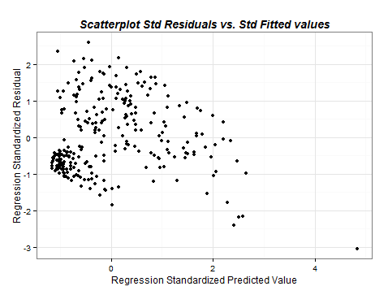

Figure 9. Normal Quantile-Quantile plot to assess normality of residuals.

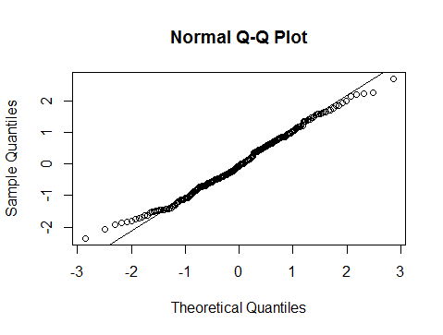

Model 2: BDI on PICDI + Self ~ Ideal Discrepancy + Polarization index + Interaction term (Index x Polarization)

Figure 10. Scatterplot of standardized residuals and fitted values to assess homoscedasticity.

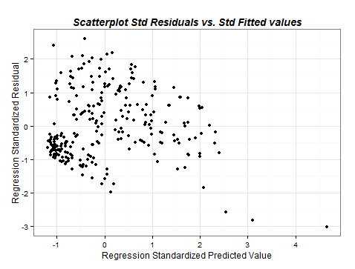

Figure 11. Normal Quantile-Quantile plot to assess normality of residuals.

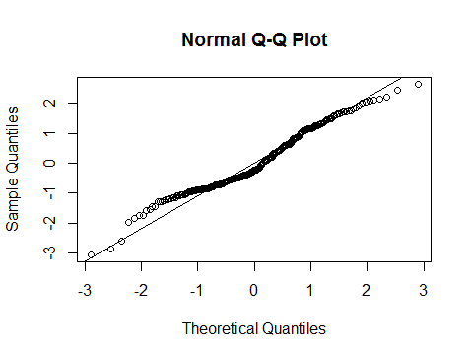

Model 3’. GAF on PDI + Self ~ Ideal Discrepancy

Figure 12. Scatterplot of standardized residuals and fitted values to assess homoscedasticity.

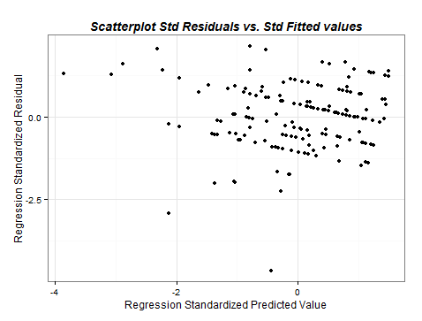

Figure 13. Normal Quantile-Quantile plot to assess normality of residuals.



Model 3, After removing the outlier. GAF on PDI + Self ~ Ideal Discrepancy

Figure 14. Scatterplot of standardized residuals and fitted values to assess homoscedasticity.

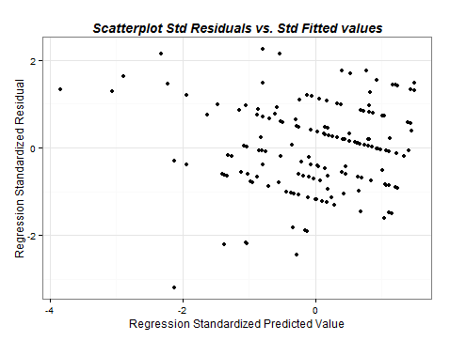

Figure 15. Normal Quantile-Quantile plot to assess normality of residuals.

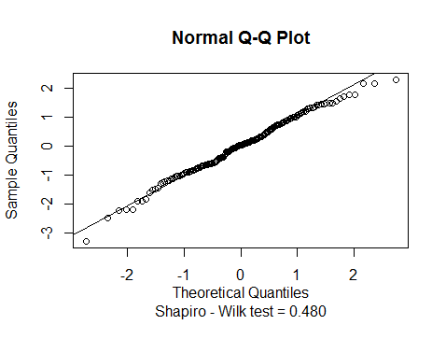

Model 4. PICDI + Self ~ Ideal Discrepancy

Without the observation no. 99

Figure 16. Scatterplot of standardized residuals and fitted values to assess homoscedasticity.

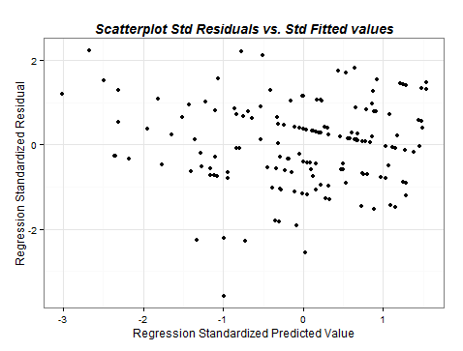

Figure 17. Normal Quantile-Quantile plot to assess normality of residuals

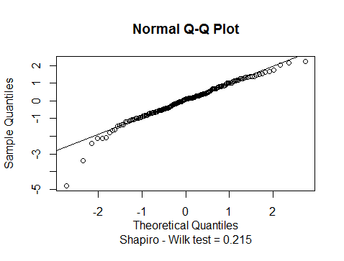

1. Such as memory, attention, distorted thoughts, beliefs or self-esteem.
2. Evidence based practice.
3. The actual self and the ideal self are in opposite poles.
4. The actual self and the ideal self are in the same pole.
5. In this case, the desired condition of the discrepant pole is “Does not depressed easily”. It would imply an undesired change in an aspect of his/her personality: to be “Selfish”.
6. One cannot by no means “assign” depression to a group of individuals, plus we did not have access to a census of depressed patients.
7. Remember that this is more suitable to interpret the results of this variable. Mean of the discrepancy = 0.42.
8. Although cognitive facets are understood as a broader phenomenon in the constructivist approach, it is clear that RGT focus on the attributional aspect of awareness rather than in a more direct perception (which can be understood as somatic – affective).
9. There may be subjects whose understanding of reality is not rigid but still score high in the index. They may perceive with nuances different objects and people in their environment while they can score high in the polarization index because of some problems regarding quantities. Measuring subjective perception of different cognitive facets (moral, spiritual, affective, political views and so on) is never easy and some subjects may experience problems quantifying them, according with the phenomena of the ineffability of subjective experience.
10. PICDI cutting scores are not that meaningful as it is still a measure under development.
11. Remember that specificity means true negative rate, complementary to the false positive ratio, i.e. the proportion of correctly classify an individual in the control sample, complementary to classify a healthy individual in the clinical sample.